**Android-Espresso**

**Create UI automate test for project by using Android-Espresso**

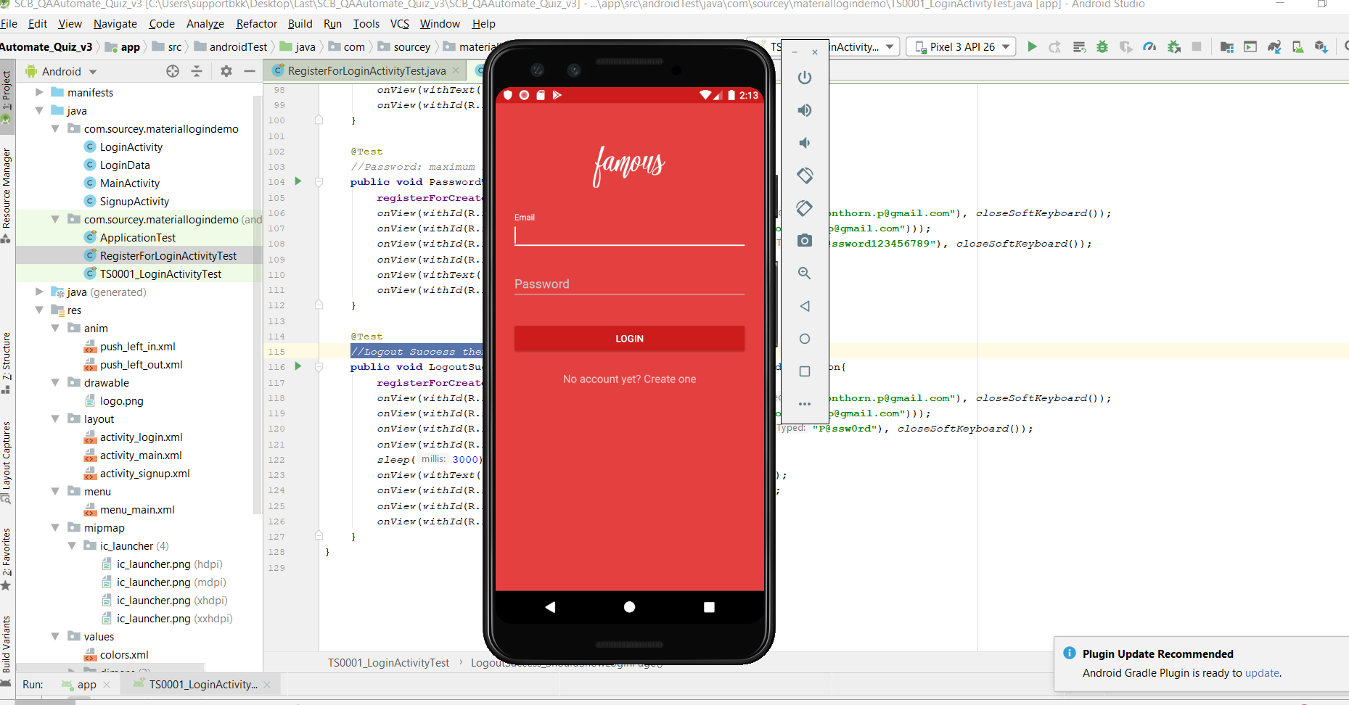

1. First create file **RegisterForLoginActivityTest.java.** for create test data (email and password) that data for login to the application.

**RegisterForLoginActivityTest.java**

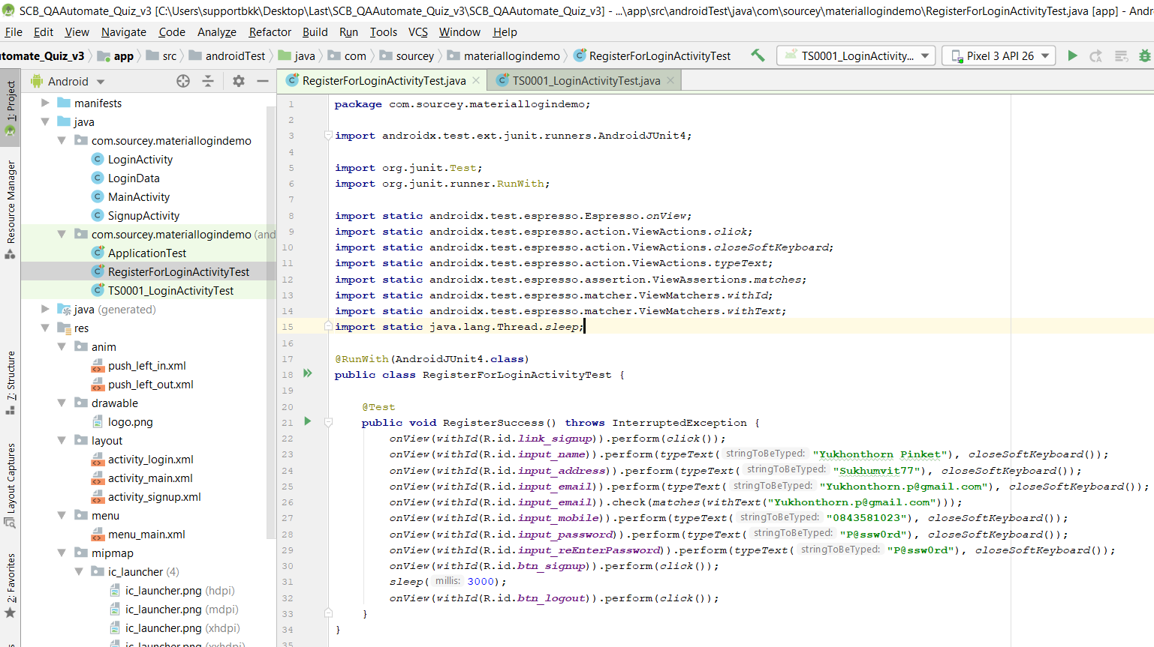

2. Create File **TS0001_LoginActivityTest.java** for test login activity.

(8 Test case).

**TS0001_LoginActivityTest.java**

Step1. Import file or Library.

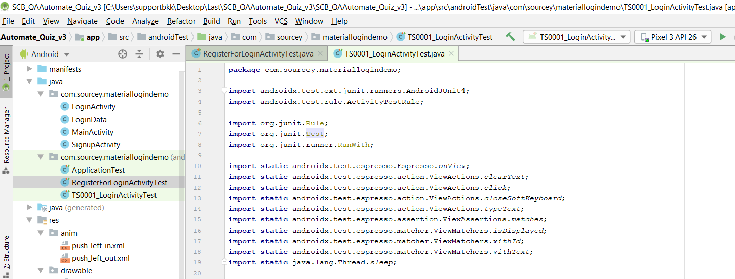

Step2. Create class and prepare data

* Create registerForCreateData for call method RegisterSuccess()
* Create @Rule mainActivityActivityTestRule that when run test case it always open MainActivity.class in the first step.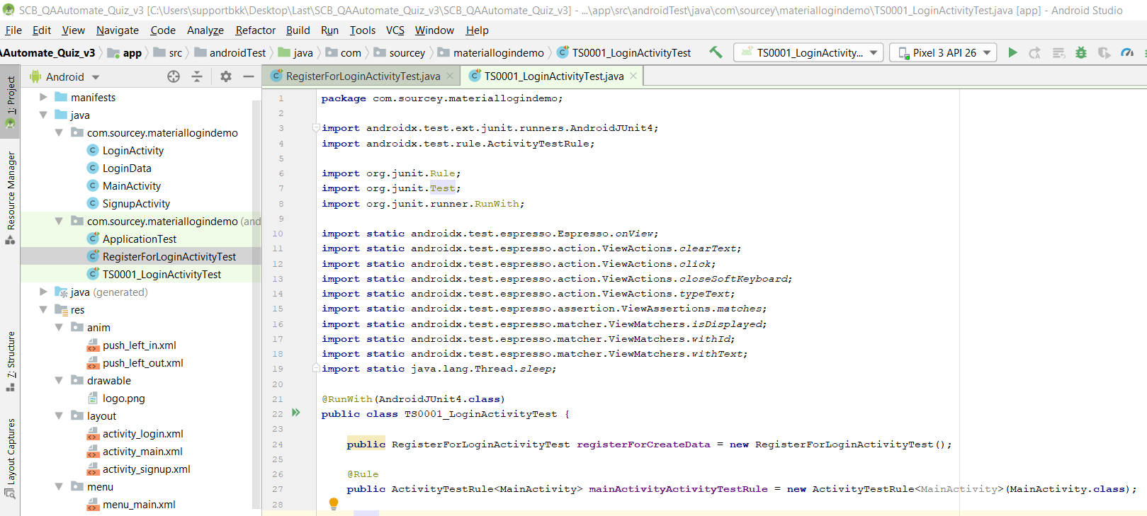

Step3: Create UI Automate test

Test1:

*//If log in success it will show ‘Material Login Example’ page.*

Step: Login success

* Register for create email and password
* Input email to email textbox as “[Yukhonthorn.p@gmail.com](mailto:Yukhonthorn.p@gmail.com)”,then close keyboard
* Check format email
* Input password to password textbox as “P@ssw0rd”, then close keyboard
* Click login button
* Wait for login
* Application should show text as “Hello World!”
* Application should show logout button

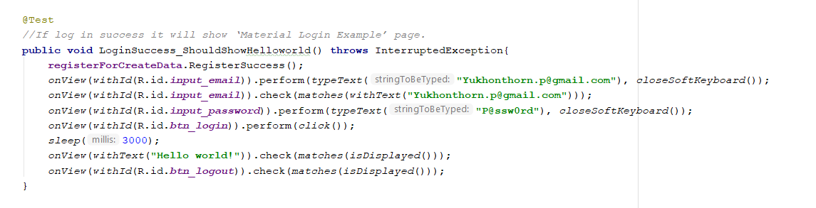

Test2:

*//Email not existing in the system.*

Step: Login Unsuccessful

* Register for create email and password
* Input email to email textbox that not existing in the system as “[Yukhonthorn.p1@gmail.com](mailto:Yukhonthorn.p1@gmail.com)”,then close keyboard
* Check format email
* Input password to password textbox as “P@ssw0rd”, then close keyboard
* Click login button
* Application should show error “enter a valid email address”
* Application should show login button

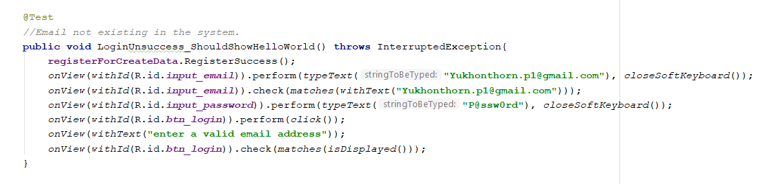

Test3:

*//Email is empty.*

Step: Email is empty

* Register for create email and password
* Input email to email textbox as “[Yukhonthorn.p@gmail.com](mailto:Yukhonthorn.p@gmail.com)”,then close keyboard
* Clear text on email textbox
* Input password to password textbox as “P@ssw0rd”, then close keyboard
* Click login button
* Application should show error “enter a valid email address”
* Application should show login button

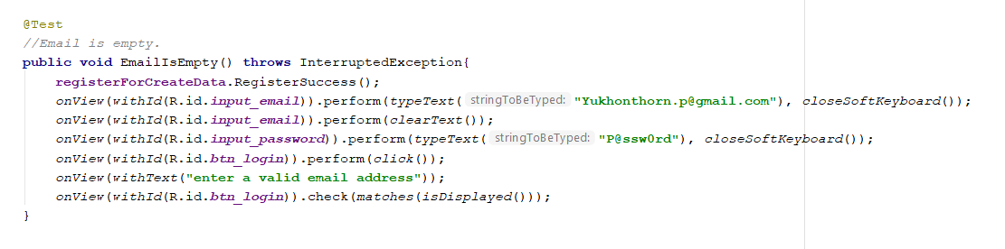

Test4:

*//Password is empty.*

Step: Password is empty

* Register for create email and password
* Input email to email textbox as “[Yukhonthorn.p@gmail.com](mailto:Yukhonthorn.p@gmail.com)”,then close keyboard
* Check format email
* Input password to password textbox as “P@ssw0rd”, then close keyboard
* Clear text on password textbox
* Click login button
* Application should show error “between 4 and 10 alphanumeric characters”
* Application should show login button

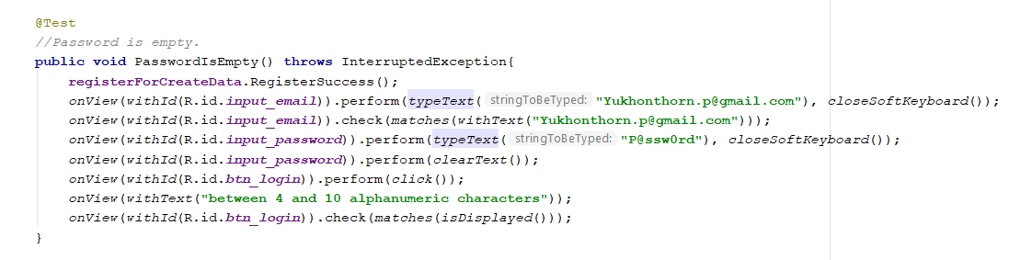

Test5:

*//Email is a user login and it will check email format*

Step: Email format

* Register for create email and password
* Input email to email textbox that incorrect format as “[Yukhonthorn.p](mailto:Yukhonthorn.p1@gmail.com)”, then close keyboard
* Input password to password textbox as “P@ssw0rd”, then close keyboard
* Click login button
* Application should show error “enter a valid email address”
* Application should show login button

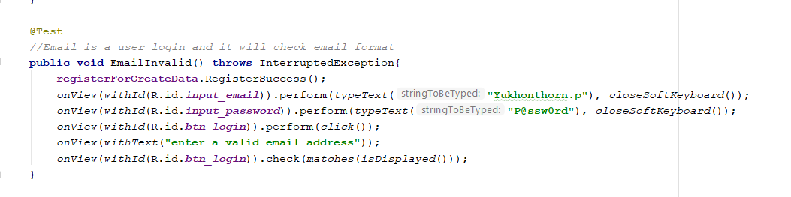

Test6:

*//Password: at least 4 character.*

Step: Password too short

* Register for create email and password
* Input email to email textbox as “[Yukhonthorn.p@gmail.com](mailto:Yukhonthorn.p@gmail.com)”,then close keyboard
* Check format email
* Input password to password textbox that less than 4 character as “P@s”, then close keyboard
* Click login button
* Application should show error “between 4 and 10 alphanumeric characters”
* Application should show login button

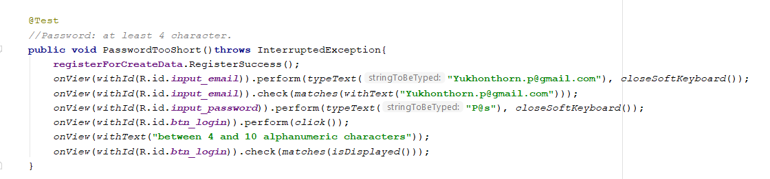

Test7:

*//Password: maximum is 10 character.*

Step: Password too long

* Register for create email and password
* Input email to email textbox as “[Yukhonthorn.p@gmail.com](mailto:Yukhonthorn.p@gmail.com)”,then close keyboard
* Check format email
* Input password to password textbox that more than 10 character as “P@ssw0rd123456789”, then close keyboard
* Click login button
* Application should show error “between 4 and 10 alphanumeric characters”
* Application should show login button

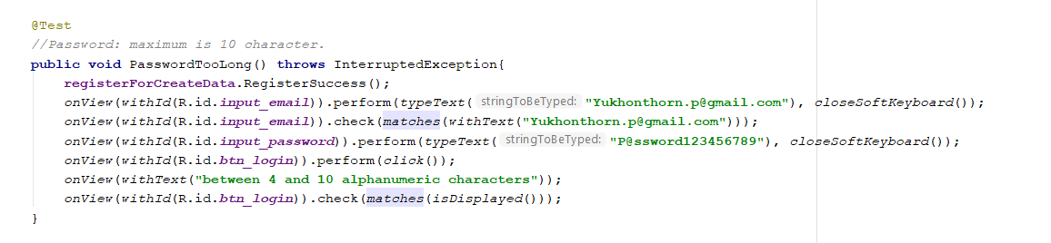

Test8:

*//Logout Success them go to the login page.*

Step: Logout success

* Register for create email and password
* Input email to email textbox as “[Yukhonthorn.p@gmail.com](mailto:Yukhonthorn.p@gmail.com)”,then close keyboard
* Check format email
* Input password to password textbox as “P@ssw0rd”, then close keyboard
* Click login button
* Wait for login
* Application should show text as “Hello World!”
* Application should show logout button
* Click logout button
* Application should show login button

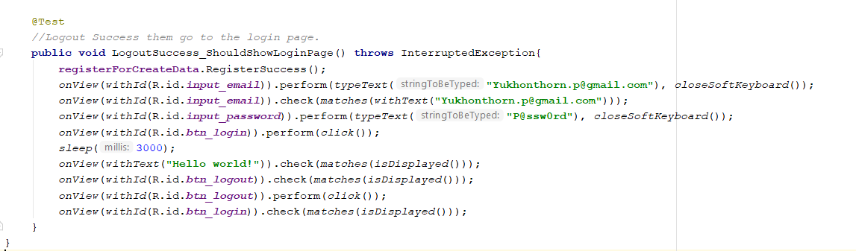

1. Log Result Test Results - TS0001_LoginActivity___.html